**Year 8 Chemistry Test**

Student Name: Tysen Bruce

Goals:

* Tysen can draw, describe and identify examples of solids, liquids and gases.
* Tysen can identify the processes that change the states of matter.
* Tysen can determine the volume being held in a measuring cylinder.
* Tysen can identify many of the first 20 symbols and elements
* Tysen can identify the number of protons, neutrons and electrons when given instructions.

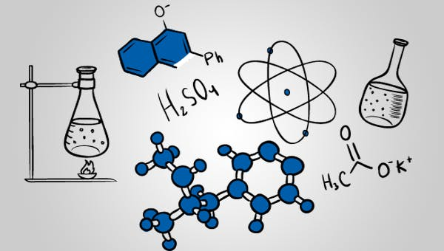

Teacher comment:

**Question 1**

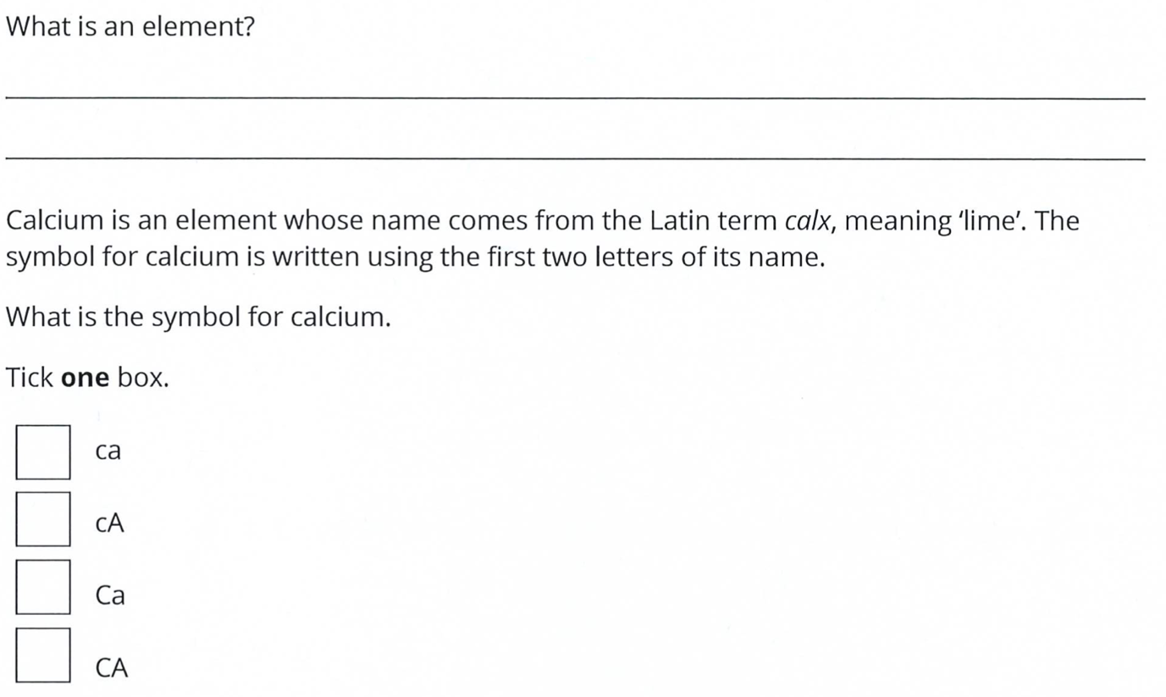

**Question 2**

**Question 3**

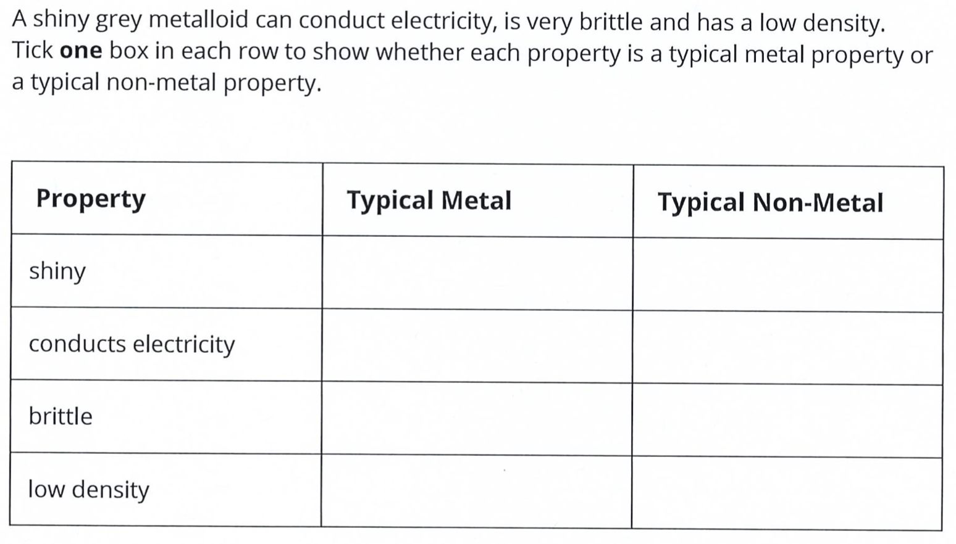

**Question 4**

Identify the change of state that is happening in each situation:

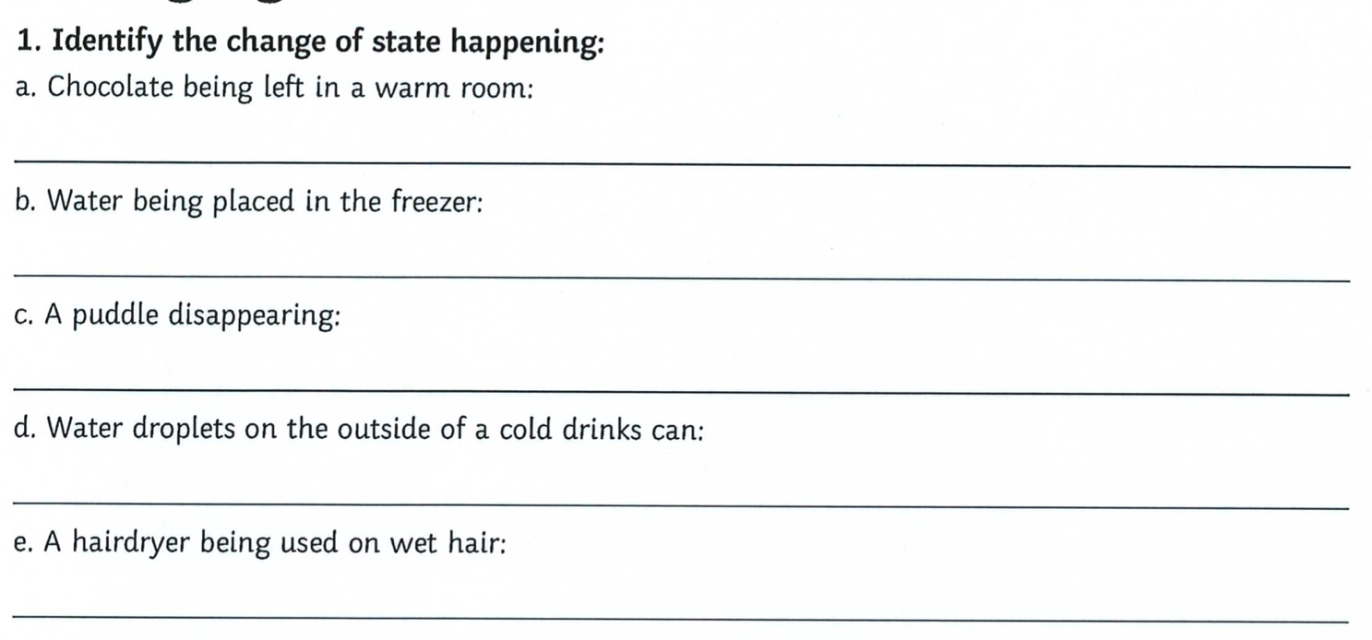

**Question 5**

In each box, write the change of state that is taking place:

Words:

Melting Freezing Condensation Evaporation

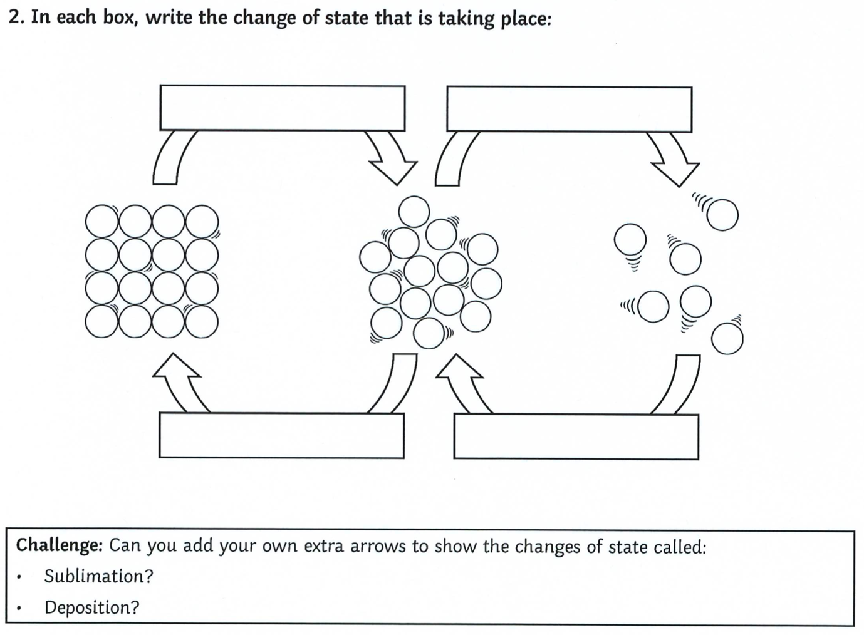

**Question 6**

Rahul takes a shower, makes a cup of tea and then hangs his washing outside to dry. For each scenario, identify the change(s) of state happening and describe what is happening to the water molecules.

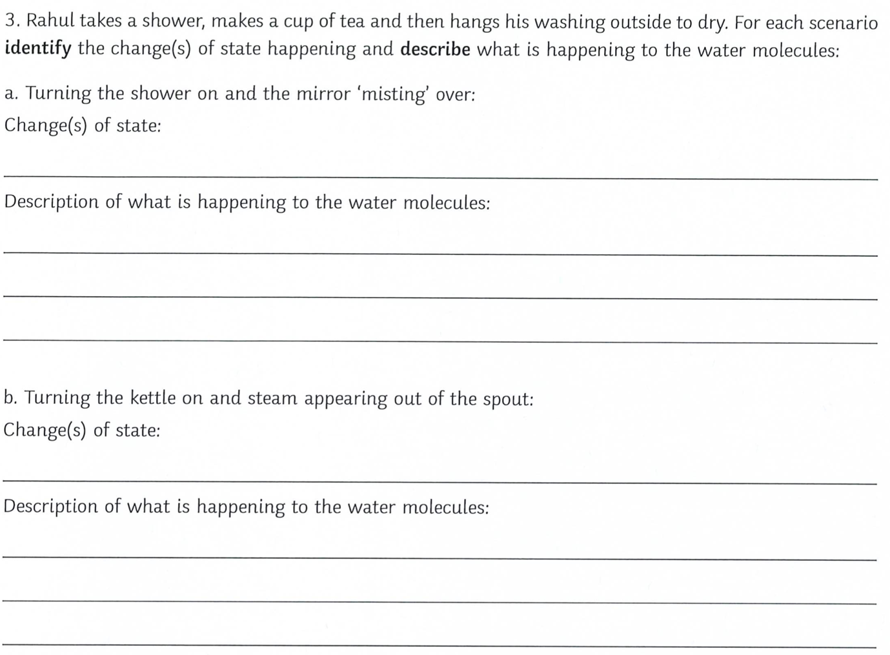

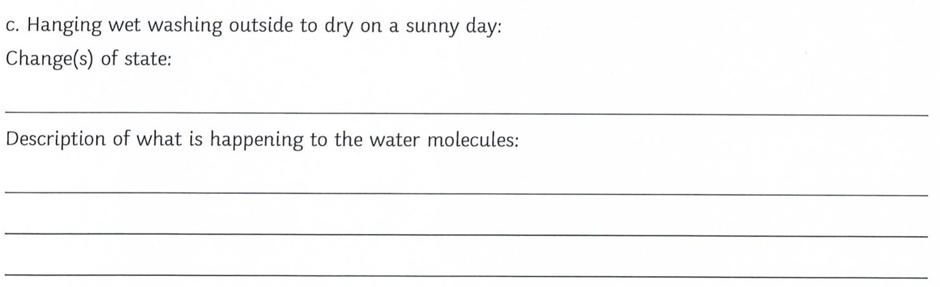

**Question 7**

For each property, explain why it is possible in terms of how the particles are arranged:

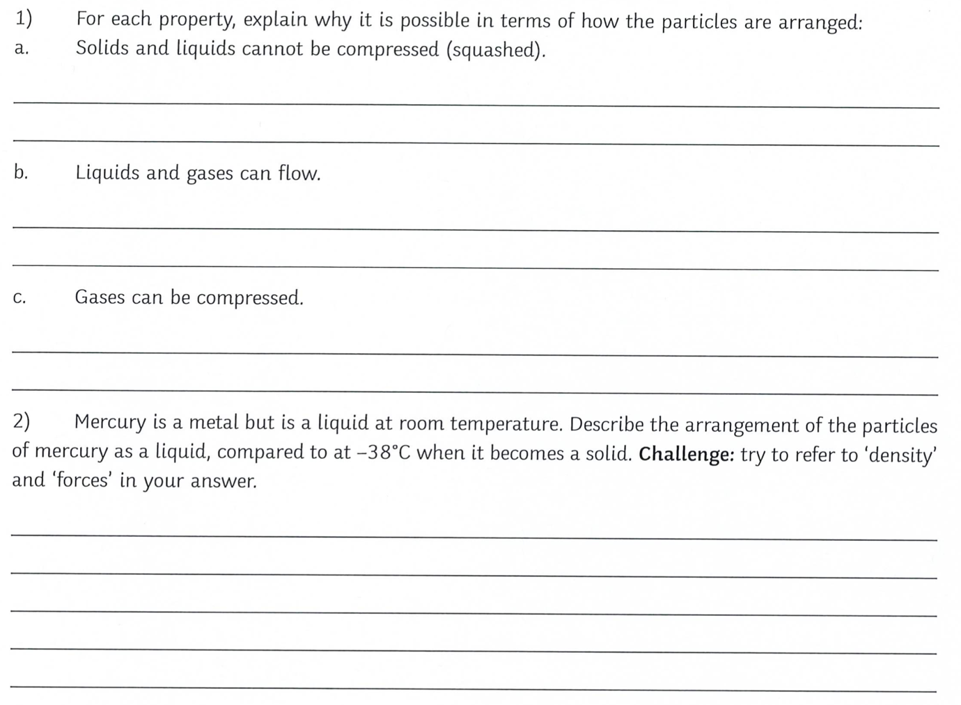

**Question 8**

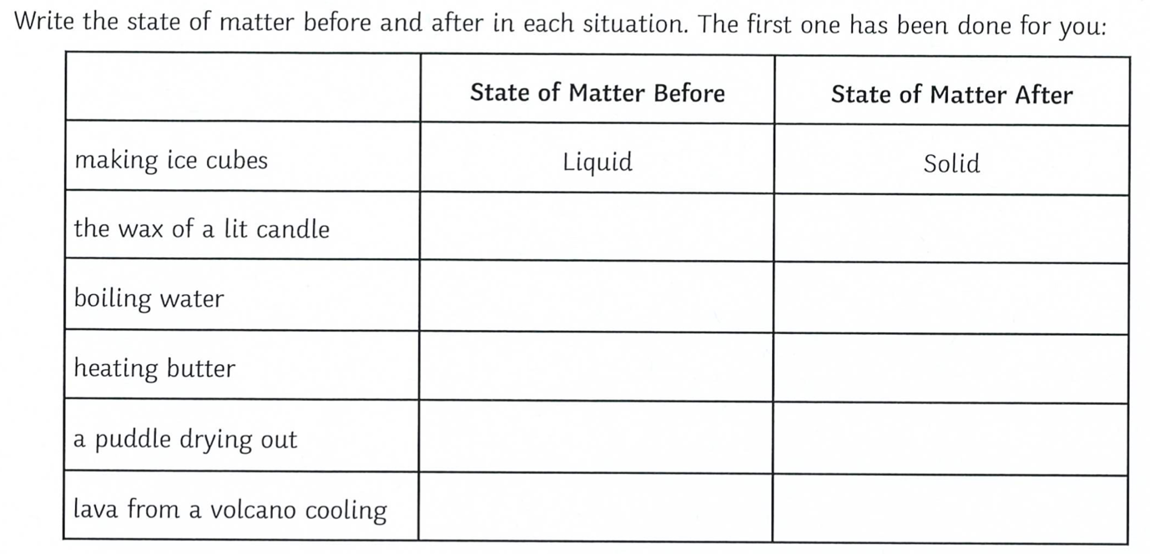

**Question 9**

1. How many protons, neutrons and electrons do each of the following atoms have?
2. For an extra challenge: Can you work out the atomic number and the atomic mass. Remember – the atomic number is number of protons in the nucleus, while the mass number is the number of protons plus the number of neutrons.
3. Can you identify which elements each atom belongs to?

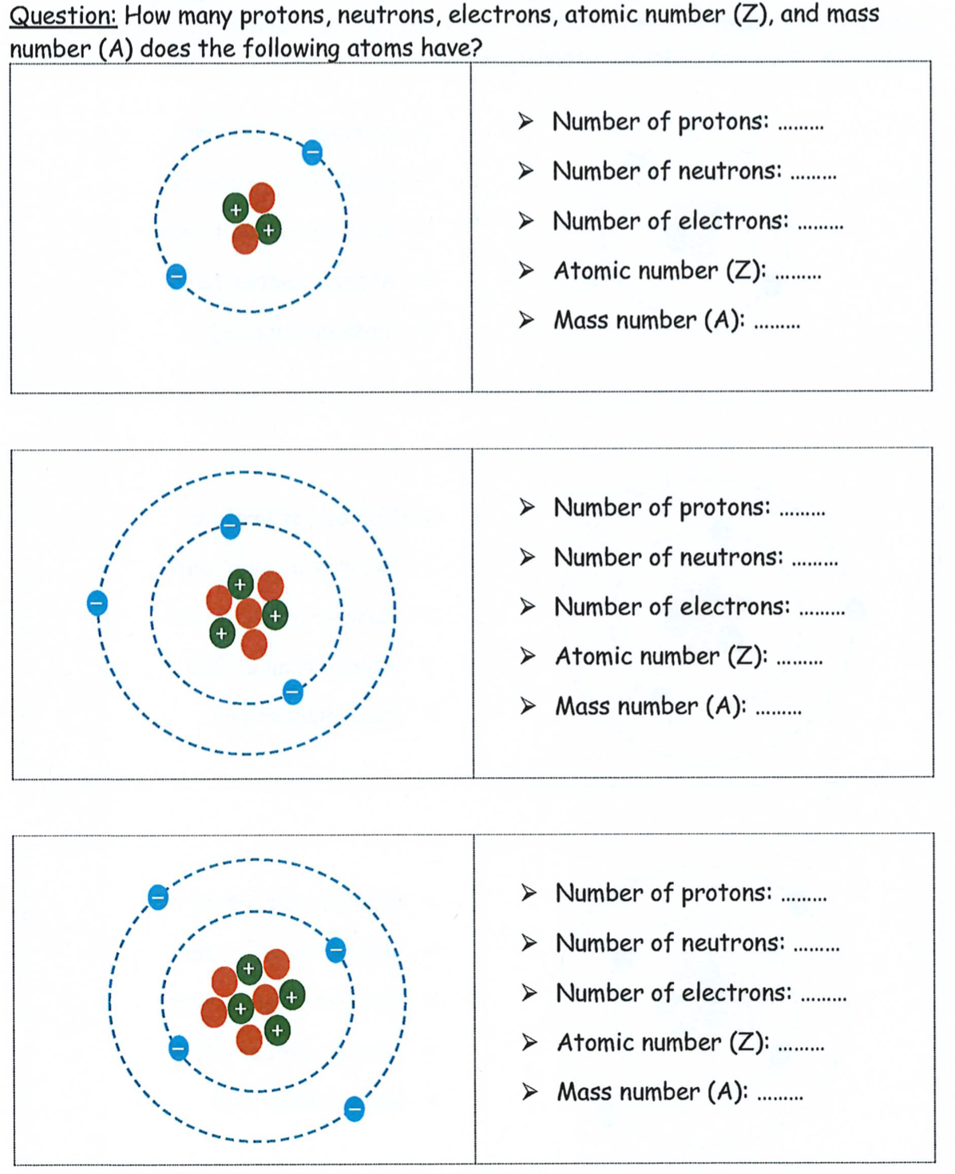

**Question 10**

Complete the table by giving the element name or symbol where appropriate.

**Question 11**

What is the reading in millilitres (mL) for each of the measuring cylinders?

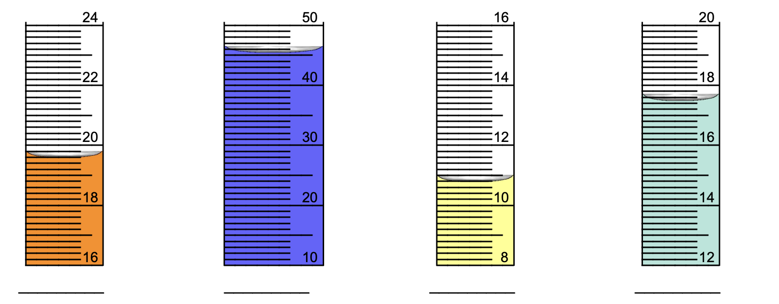

**End of Test**